- Domain____________________ 3. Domain______________________
Range_____________________ Range_______________________
Max or Min_________________ Max or Min_________________
End Behavior_______________ End Behavior___________________
Parent Function______________ Parent Function_______________
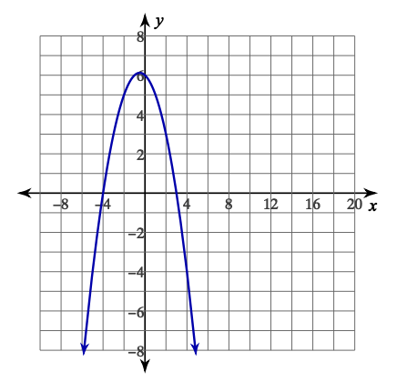
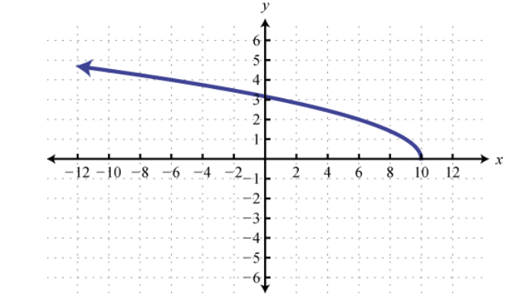

- Domain_________________ 4. What is the Range of the following Graph?
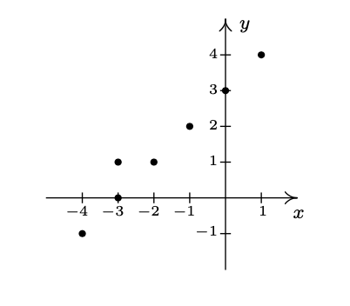
Range__________________
End Behavior____________
Max or Min______________
Parent Function_____________
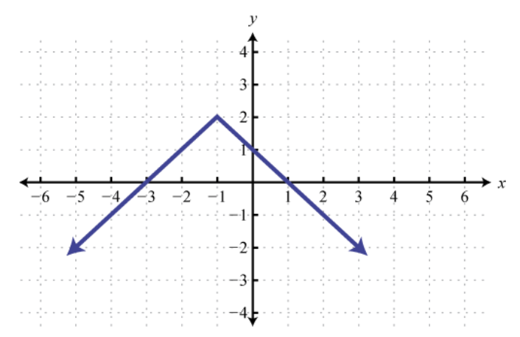

What is the range of the graph?__________
Is this the graph of a function?___________
Justify your answer.___________________
___________________________________
___________________________________

5. The graph below shows the crude oil production 6. How do the graphs of $f(x) =x^{2}$ and $g(x)=\sqrt{x}$
for Alaska Oil company. Select the correct Compare? Circle all that apply.
domain and range.
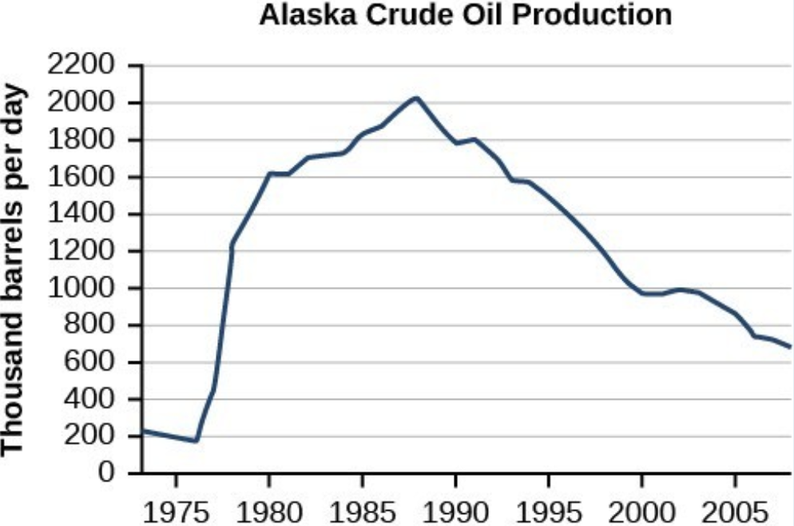
a) They have the same domain
b) They have the same range
c) They have the same x- intercept
d) They have the same minimum value
\ e) They have the same end behavior as $x→+∞$
f) They have the same end behavior as $x→ -∞$
_____________________________________________

8. Use the graph of $f(x)$ to determine which statement is
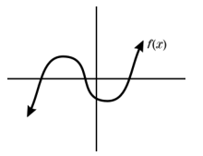
FALSE.
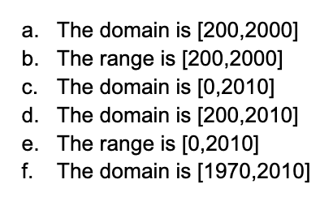

- The domain and range of this function are not equal
- The domain of $y=|x|$is the same as the domain of $f$
- The range of $y=x$ is the same as the range of $f$
- $f$ is a discrete function
______________________________________________
7. A bird is building a nest in a tree 36 feet above 9. A class had a contest to guess how many
the ground. The bird drops a stick from the nest. marbles are in a jar. There were 47 marbles
The function in the jar. The student’s guesses are shown.
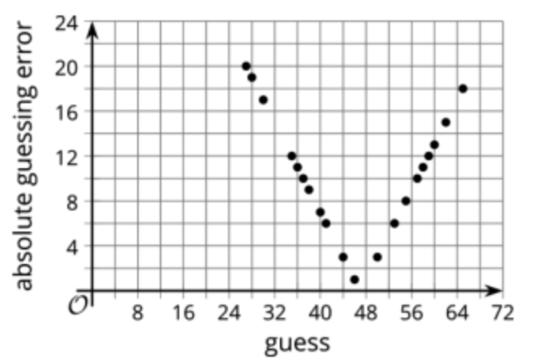
$h(t)=16t^{2}+36$
describes the height of the stick in feet t seconds
After it was dropped, where t represents the
height of the stick.
Which of the following is the most reasonable
range for this situation?

- $[0,36]$ c. $[0,∞)$
- $(-∞,36]$ d. All real Numbers
Based on the graph, approximately what is the
margin of error?________________
If a mistake was made and there were actually 43
marbles in the jar, how would the graph change?
________________________________________

